**Te Āwhina Marae o Motueka Society Incorporated**

**Expression of Interest Application Form**

**Papakāinga Housing**

**05 July 2024**

**Currently all whare are allocated in the Papakāinga and we are taking a waitlist. We will have six 2-bedroom whare becoming available in November 2024. All applicants will be asked to participate in an interview.**

**Applications can be sent to:**

Kaiāwhina o te Papakāinga: Jacinda Piggott

Te Āwhina Marae, 133 Pah Street, Motueka

Email: [jacinda.piggott@tam.org.nz](mailto:jacinda.piggott@tam.org.nz)

03 5286061

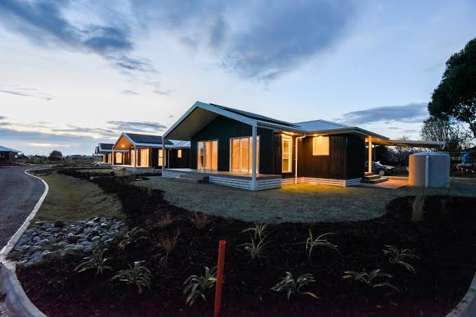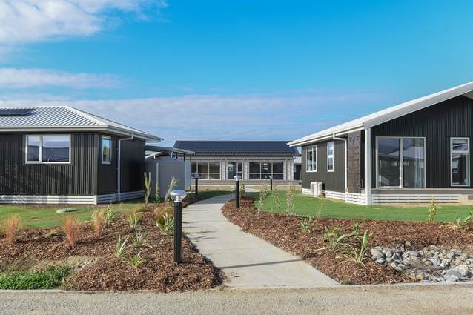

*Information provided in your application will only be used for the purposes of assessing eligibility for the Papakāinga houses. Te Āwhina Marae will keep all information confidential and put in place appropriate measures to ensure that identifying information is not unnecessarily disclosed through the assessment and allocation process. The request for Expression of Interest for the Papakāinga does not guarantee that an applicant will be successful. The final decision for the allocation of Papakāinga houses will be determined by the board of Te Āwhina Marae.*

Table of Contents

1. Introduction to the Papakāinga 3

2. Eligibility Criteria 5

3. Expression of Interest Application Form 6

4. Signed Declaration 11

5. Te Awhina Marae Contact Details 11

Only:

# 1. Introduction to the Papakāinga

Te Āwhina Marae stands under our two maunga: Pukeone and Tu Ao Wharepapa. Our awa, Motueka run swiftly, bringing life and nourishment to our rohe. Our whānau are connected to the iwi of Te Ātiawa and Ngāti Rārua and our hapū entities Whakarewa Trust and Wakatū Incorporation. Our wharenui is named after the ancestor Tūrangaapeke.

For the past 15 years, Te Āwhina Marae (TAM) has been undertaking the planning and implementation of a major redevelopment of the whole Marae complex. The aim of the Marae redevelopment programme is to develop a hapū enabled community Marae that meets the cultural and spiritual needs of our whānau, is efficiently designed, resilient to natural hazards which are occurring with increasing frequency and is environmentally and financially sustainable for the next 100 years.

There are four stages to the TAM Redevelopment. One of the stages is the Papakāinga Housing Development. Our vision for the Papakāinga is:

*To create a thriving and sustainable community that is safe, healthy and prosperous for whānau.*

There are 26 **whare for whānau** and the table below provides the details of the number of whare that are available and size of the whare.

*Table 1: Number of whare and size of whare.*

|  |  |  |
| --- | --- | --- |
| 2 Bedroom | 3 Bedroom | 4 Bedroom |
|  | 4 |  |
|  | 2 | 2 |
|  | 2 | 2 |
| 4 |  |  |
| 4 |  |  |
| 6 (on the Marae complex) |  |  |
| 14 | **8** | **4** |

We encourage you to apply for a whare and you must complete an Expression of Interest Application Form that is provided in Section 3. **All applicants must complete an Expression of Interest Application form** which will be kept in their file, should they become tenants and **selected applicants will attend an interview for the whare**.

# 2. Eligibility Criteria

To be eligible for a whare in the Papakāinga development you must meet the criteria

outlined below.

The tenants must bekaumātua, individuals and whānau who belong to (in order):

* Mana Whenua (Ngāti Rārua and Te Ātiawa ki Motueka);
* Registered shareholders of Wakatū Incorporation who whakapapa to those original tupuna (the 254) identified by the Native Land Court in 1892 and listed on the 1892 list of original owners;
* Registered members of the iwi entities of Ngāti Rārua and Te Ātiawa ki Te Tauihu;
* Registered members of the iwi entities of Ngāti Tama and Ngāti Koata;
* Registered members of the iwi entities of Kurahaupō ki Te Tauihu / Mataawaka; and
* Community members.

All tenants will also need to contribute actively to the Te Āwhina Marae (TAM) community which means that they will:

1. Contribute to the cultural, social and environmental well-being of TAM. This could include supporting with pōwhiri, paepae, tangihanga, wharekai duties, hosting, parekore (waste programme), maara kai etc;
2. Uphold the tikanga and values of TAM;
3. Participate in identified programmes of TAM and the papakāinga which could include: financial literacy, arts, nutrition, gardens, maara kai, working bees etc;
4. Participate in TAM whānau, hapū, Marae and papakāinga meetings (where applicable);
5. Understand and adhere to the policies of TAM i.e. Papakāinga, Tupono, Alcohol / Drugs / Smoking, Health and Safety etc; and
6. Any other reasonable requests that will benefit TAM and the whānau and hapū of TAM.

*In addition to the above:*

1. **All applicants will complete an Expression of Interest Application form** which will be kept in their file, should they become tenants;
2. **Selected applicants will attend an interview for the whare**;
3. The relevant policies will be made available to tenants;
4. TAM will ask for a police and credit check of applicants; and
5. The final decision on tenant selection will be decided by the TAM Board.

# 3. Expression of Interest Application Form

**A. Applicant Details**

|  |  |  |
| --- | --- | --- |
|  | Applicant 1  (Primary) | Applicant 2 |
| Full name  (If more than 2 applicants, please add details on another page) |  |  |
| Date of Birth |  |  |
| Address |  |  |
| Phone |  |  |
| Email |  |  |

**B. Eligibility**

Do you belong to:

(Please circle)

|  |  |  |
| --- | --- | --- |
|  | Applicant 1  (Primary) | Applicant 2 |
| Ngāti Rārua and Te Ātiawa ki Motueka | Yes No | Yes No |
| Wakatū Incorporation and you whakapapa to those original tupuna (the 254) identified by the Native Land Court in 1892 and listed on the 1892 list of original owners | Yes No | Yes No |
| Te Rūnanga o Ngāti Rārua –registered member | Yes No | Yes No |
| Te Ātiawa o Te Waka-a-Māui –registered member | Yes No | Yes No |
| Ngāti Tama ki te Waipounamu Trust – registered member | Yes No | Yes No |
| Ngāti Koata Trust – registered member | Yes No | Yes No |
| Te Rūnanga o Toa Rangatira – registered member |  |  |
| Te Rūnanga a Rangitane o Wairau - registered member | Yes No | Yes No |
| Ngāti Apa ki te Ra To Trust - registered member | Yes No | Yes No |
| Ngāti Kuia - registered member | Yes No | Yes No |
| Mataawaka* | Yes No | Yes No |
| Tangata Tiriti / Community Member | Yes No | Yes No |

*Please provide your Iwi affiliations __________________________

**C. Dependents**

|  |  |  |
| --- | --- | --- |
|  | Applicant 1 | Applicant 2 |
| Do you have dependents (i.e. who either live with you or who you support financially?)  (Please circle) | Yes No | Yes No |
| How many? |  |  |
| How many live with you? |  |  |

**D. Current Living Arrangements**

|  |  |  |
| --- | --- | --- |
|  | Applicant 1 | Applicant 2 |
| What is your current address? |  |  |
| How long have you lived at this address? | Years | Years |
| Current living arrangements  (Please circle) | Rent  Own House  Boarding  Living with Family  Other | Rent  Own House  Boarding  Living with Family  Other |
| Who do you currently live with? |  |  |

**E. Employment Details**

|  |  |  |
| --- | --- | --- |
|  | Applicant 1 | Applicant 2 |
| Occupation |  |  |
| Name of Employer |  |  |
| Contact Details of Employer |  |  |
| How many years worked for current employer? |  |  |

**F. Housing Information**

|  |  |
| --- | --- |
| What size whare would you like to be considered for?  (Please circle) | Two bedroom  Three bedroom  Four bedroom |
| Who do you think will live with you while you are renting the whare? How old are each of these people? What is their relationship to you? | Name  Age  Relationship  Name  Age  Relationship  Name  Age  Relationship  Name  Age  Relationship  Name  Age  Relationship  Name  Age  Relationship |
| Any health or disability issues / barriers that you would like to share with us  (Please circle) | Yes No |
| If you answer yes to the above, please explain what these are |  |
| Are you or anyone who will be living in the whare registered on the MSD Public / Social Housing register?  (Please circle) | Yes No |
| If you are not registered on the MSD Public / Social Housing register, are you open to meeting with a representative from MSD to discuss if this is an option?  (Please circle) | Yes No |

**G. Community**

|  |  |
| --- | --- |
| What is the main reason for wanting to remain in / move to the Papakāinga? |  |
| Do you currently do any activities that contribute to Te Āwhina Marae and our iwi / hapū entities ?  (Please circle) | Yes No |
| What are they? (These contributions may be to the social, cultural, spiritual well-being of the whānau, hapu, iwi, community) |  |
| If you don’t currently live in Motueka, how would you contribute to the wellbeing of Te Āwhina Marae if you moved to the Marae? |  |
| Is Te Reo spoken in your home? If yes, please indicate the percentage of general conversation that occurs in Te Reo  (Please circle) | Yes No  10% 25% 40% 50% >50% |
| What are your aspirations for you and your whānau in relation to home ownership? |  |

**H. Other**

|  |  |
| --- | --- |
| Is there anything else you would like to tell us that you think is relevant to your housing requirements? |  |
| Do you consent to Te Āwhina marae:   * Obtaining a credit check for you * Obtaining a police check for you   (Please circle) | Yes No  Yes No |
| We would like to contact two referees. Please provide the details of two referees who are a **current or previous landlord** and an employer or a community referee. | Name of referee:  Relationship:  Contact phone number:  Email:  Name of referee:  Relationship:  Contact phone number:  Email: |

# 

# 4. Signed Declaration

The answers to the questions given above are true and correct as at the date of this Expression of Interest Application**.**

**APPLICANT 1:**

**FULL NAME SIGNATURE**

**APPLICANT 2:**

**FULL NAME SIGNATURE**

**DATE OF APPLICATION:**

# 5. Te Awhina Marae Contact Details

Te Āwhina Marae will conduct the tenant process for the Papakāinga. Any questions you may have can be directed to:

Jacinda Piggott

Kaiāwhina o te Papakāinga

Te Āwhina Marae o Motueka Incorporated Society

[**jacinda.piggott@tam.org.nz**](mailto:jacinda.piggott@tam.org.nz%20)

03 5286061

|  |  |  |
| --- | --- | --- |
| Te Āwhina Marae Office Use Only | Applicant Reference Number |  |
|  | Application Complete | Yes No |
|  | Additional Information Required | Yes No |
|  | Applicant Meets Criteria | Yes No |
| Other |  |  |